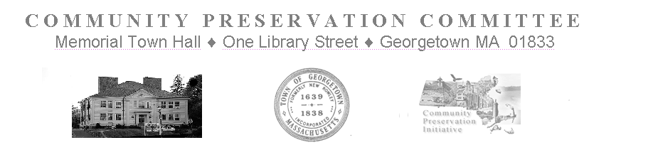

Community Preservation Committee Meeting
Tuesday, March 7, 2023
Held at 7:00 PM
Via Zoom Meeting
https://us02web.zoom.us/j/81107214933

This Public Meeting is being conducted in a way that is an attempt to satisfy the Open Meeting Law, and other State Laws pertaining to the Public Hearings of the Town’s Public Bodies. It is a good faith, best effort to comply with the pandemic extensions signed into law on June 16, 2021 in Chapter 20 of the Acts of 2021 and further extended through March 31, 2023 by Chapter 22 of the Acts of 2022. Internet based technologies will be used by the CPC to conduct Public Meetings and Hearings until further legislative changes are enacted, or the extension expires.

Meeting Minutes

In attendance: H. LaCortiglia, R. Bancroft, T. Ruh, G. Fowler, S. Epstein (leaves at 7:17), P. Burns J. DiMento(arrives at 7:18) R Bancroft (leaves at 8:17pm)
Not in attendance:, J. Davenport, D. Schauer
Meeting is Called to Order at 7:02pm

- Invoices:
  - None
- Correspondence:
  - None
- Minutes Discussion:
  - S. Epstein questioned the adequacy of the Agenda in general and would be leaving after Minutes Discussion as the item "Project Recommendations and Amounts Vote" should have listed the items.
S. Epstein asked that at future meeting he would like the following to be Agenda Item(s) at which the CPC discusses and perhaps acts upon four questions:
Having someone other than the chair prepare the minutes? Perhaps appoint member as clerk to do so, or pay someone?;
Having minutes once written submitted to next public meeting for correction, if any thought needed, then approval by vote?; and,
Having minutes reference url to zoom recording or GCTV recording?

- New Business:
      - Additional Project Info
      - Members are informed of information recently received related to the projects below.
        - East Main Street Recreational Facility – Cost estimate of $31,035.00
        - American Legion Park ADA – Cost estimate of $31,962.00
      - Project Withdrawal
        - Members are informed that the Invasives Mapping project has been withdrawn

    - Project Recommendations and Amounts Vote
Members make the following Recommendations with amounts of recommended appropriations from the Community Preservation Trust Fund

Motion by T. Ruh To Recommend to Town Meeting CPA Reserves for the 3 core categories of the Fund in the amount of $140,000.00 each, with an Administrative Reserve of $21,000.00.
Seconded by J. Dimento
(T. Ruh shows a spreadsheet of finances and Members discuss the motion)
- Roll call vote is taken
- R. Bancroft-yes
- P. Burns-yes
- T. Ruh-yes
- J. DiMento-yes
- G. Fowler- yes
- H. LaCortiglia-yes
Motion Carries 6-0 unanimously
Motion by J. DiMento - To Recommend to Town Meeting the American Legion Park Irrigation project with an appropriation in the amount of $ 10,600.00
Seconded by G. Fowler
(Members discuss the motion)
- Roll call vote is taken
- R. Bancroft yes
- P. Burns yes
- T. Ruh yes
- J. DiMento yes
- G. Fowler yes
- H. LaCortiglia yes
Motion Carries 6-0 unanimously

Motion by J. DiMento - To Recommend to Town Meeting Greenway Park Irrigation (East Main Street Recreational Area) with an appropriation in the amount of $ 31,035.00
Seconded by G. Fowler
(Members discuss the motion)
- Roll call vote is taken
- R. Bancroft yes
- P. Burns yes
- T. Ruh yes
- J. DiMento yes
- G. Fowler yes
- H. LaCortiglia yes
Motion Carries 6-0 unanimously

Motion by J. DiMento - To Recommend to Town Meeting the American Legion Park ADA project with an appropriation in the amount of $ 14,946.00
Seconded by Tim Ruh
(Members discuss the motion)
- Roll call vote is taken
- R. Bancroft yes
- P. Burns yes
- T. Ruh yes
- J. DiMento yes
- G. Fowler yes
- H. LaCortiglia yes
Motion Carries 6-0 unanimously

Motion by T. Ruh - To Recommend to Town Meeting the Town Hall Windows Restoration Project with an appropriation in the amount of $ 457,000.00
Seconded by G. Fowler
(Members discuss the motion)
- Roll call vote is taken
- R. Bancroft yes
- P. Burns yes
- T. Ruh yes
- J. DiMento yes
- G. Fowler yes
- H. LaCortiglia yes
Motion Carries 6-0 unanimously
(R. Bancroft leaves the meeting)
Motion by T. Ruh - To Recommend to Town Meeting the Records Preservation Project with an appropriation in the amount of $ 230,000.00
Seconded by P. Burns
(Members discuss the motion)
- Roll call vote is taken
- P. Burns yes
- T. Ruh yes
- J. DiMento nay
- G. Fowler nay
- H. LaCortiglia yes
Motion Carries 3 yes-2 nay

Motion by T. Ruh - To Recommend to Town Meeting the Affordable Housing Trust Block Grant with an appropriation in the amount of $ 595,000.00
Seconded by P. Burns
(Members discuss the motion)
- Roll call vote is taken
- P. Burns yes
- T. Ruh yes
- J. DiMento yes
- G. Fowler yes
- H. LaCortiglia yes
Motion Carries 5-0 unanimously

Motion by G. Fowler - To recommend that the Town Hall Windows project appear and be voted upon at the Special Town Meeting this May.
Seconded by P. Burns
(Members discuss the motion)
- Roll call vote is taken
- P. Burns yes
- T. Ruh yes
- J. DiMento yes
- G. Fowler yes
- H. LaCortiglia yes
Motion Carries 5-0 Unanimously

- Old Business:
      - Member Concerns
        - G. Fowler expresses his desire to hold the meetings in person
        - No motions are made to this effect.

- Meeting Schedule:
      - Draft Meeting Schedule.
      - April 4th, 2023 is the announced date of the Annual Public Informational Hearing. Unless the legislature acts soon to extend Remote Participation this Hearing will need to be held in person.
Motion by J. DiMento to adjourn
Seconded G. Fowler
- Roll call vote is taken
- P. Burns yes
- T. Ruh yes
- J. DiMento yes
- G. Fowler yes
- H. LaCortiglia yes
Motion Carries 5-0 Unanimously
Meeting is adjourned at 8:45PM

