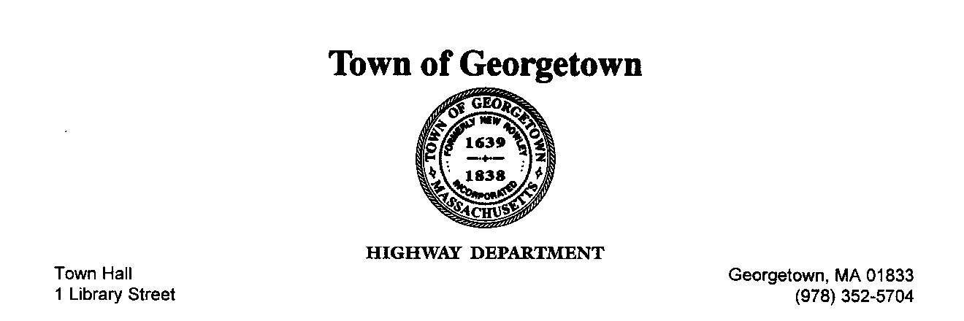

Job Posting

Summer Help

Start Date: Immediately

Job Description:

Responsibilities include, but are not limited to the following: skilled manual work to support the repair and maintenance of town roads, drainage systems, tree work, parks and ground maintenance and other town infrastructure.

Requirements:

Valid Driver’s License

Ability to lift 50lbs

Pass drug test and physical

Qualified Candidates should submit cover letter and resume including three references to:

Peter Durkee
1 Library Street
Georgetown, MA 01833

pdurkee@georgetownma.gov

Town of Georgetown is an equal opportunity employer

